Tableau Dashboard Reflection :
The Tableau dashboard can help a sales manager make a decision about which regions and product categories require additional attention. For example, a manager can use the geographic map to identify a region with lower sales performance, use the category bar chart to determine which product category is responsible for the weak performance, and use the sales trend line to understand whether the decline is temporary or part of a longer-term trend.
The decision supported by this dashboard is a semi-structured decision. It is not completely structured because the manager cannot rely only on a fixed rule to decide what action should be taken. The dashboard provides quantitative information such as regional sales, category performance, rankings, and sales trends, but the manager still needs to interpret the information and decide whether to increase marketing, change inventory levels, provide sales incentives, or take another action.
The interactive filters, parameters, drill-down hierarchy, and dashboard action filter allow the manager to investigate the data from different perspectives before making the decision. For example, the manager can select a particular region and category and then examine the corresponding sales trend. Therefore, the dashboard acts as a decision-support tool by combining multiple views of sales information and helping the manager make an informed business decision.
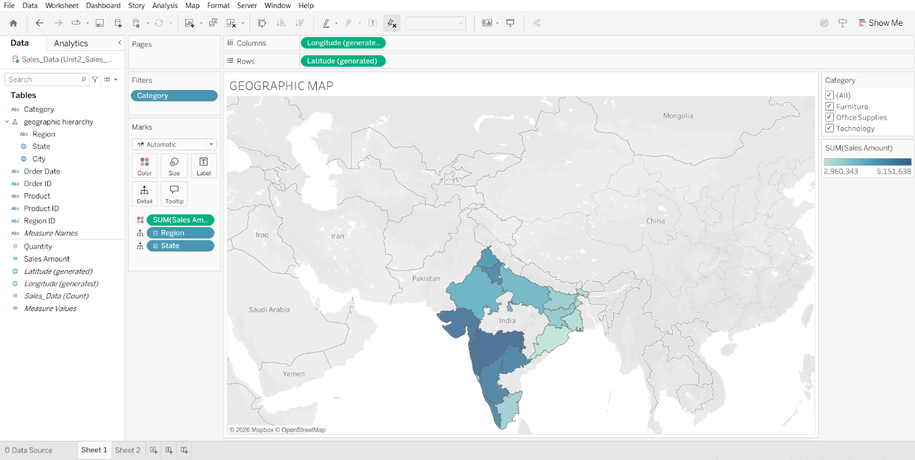
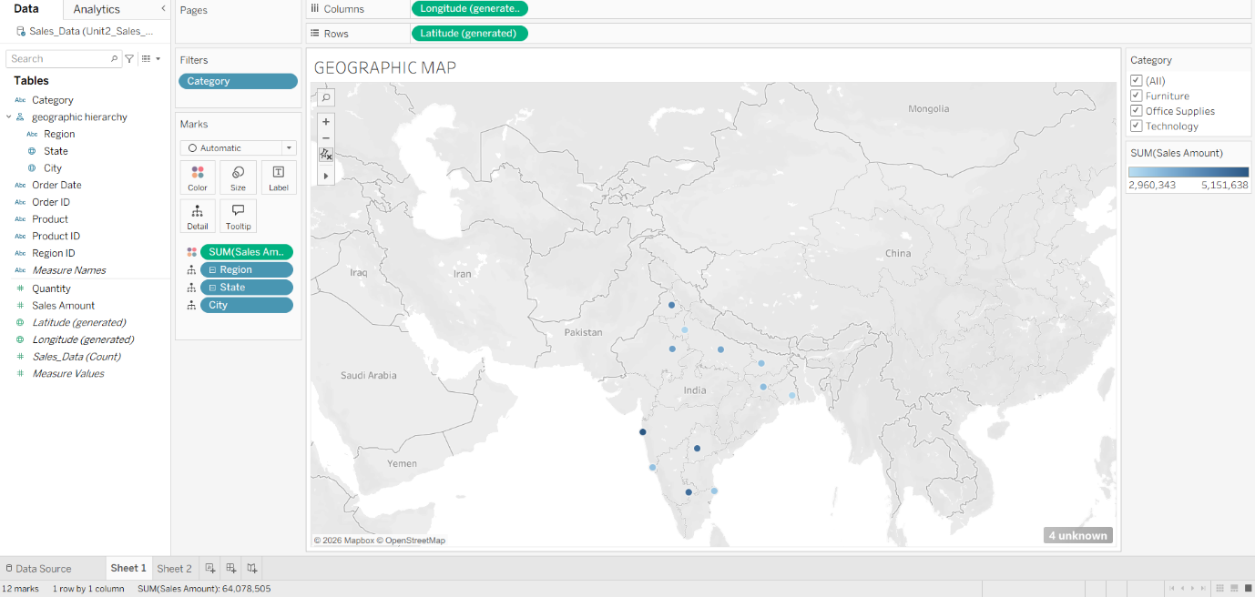

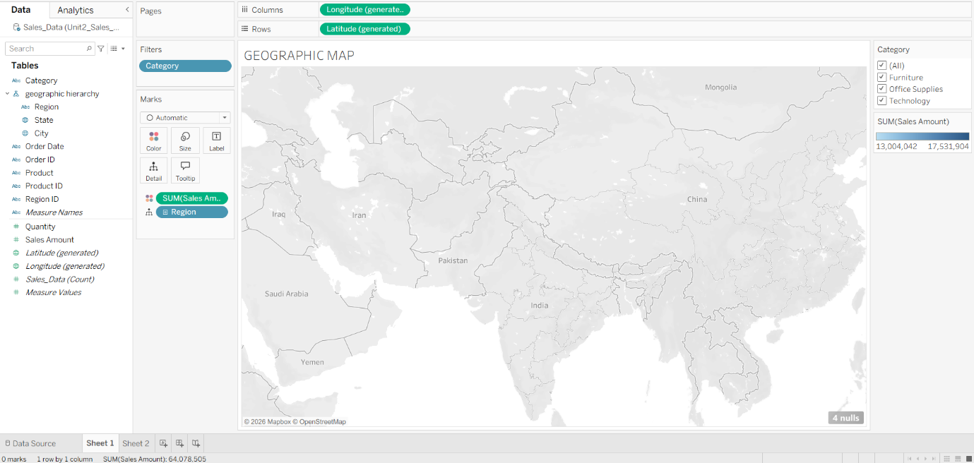

DASHBOARD :
